J  J  j | 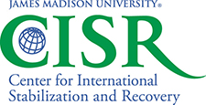 | 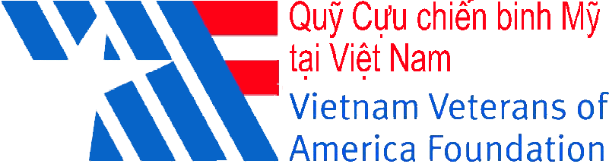

Fourth Meeting of the States Parties to the Convention on Cluster Munitions
Side-event on

Mine/Explosive Remnants of War Victim Assistance: what role for information management systems?
Co-organised by the Geneva International Centre for Humanitarian Demining (GICHD), the Vietnam Veterans of America Foundation (VVAF) and the Center for International Stabilization and Recovery (CISR)
12 September 2013, 13.00 – 14.00

Chair
- Dr. Ken Rutherford, JMU-CISR Director, United States

Panelists
- Ambassador Stephan Husy, GICHD Director, Switzerland
- Ms. Ana Maria Arango, GICHD consultant, Colombia
- Dr. Ken Rutherford, JMU-CISR Director, United States
- Ms. Thao Griffiths, IC-VVAF Country Director, Vietnam
- Mr Loren Persi Victim Assistance Coordinator, Landmine and Cluster Munition Monitor

Session objective
The proposed break-out session aims to provide several insights into the current range of persons with disability (PWD) tracking systems around the world, specifically relating to mine/explosive remnants of war (ERW) survivor/victim assistance, and information management.

Through selected case studies of national contexts, the session will address the following key questions:
- What data and surveillance requirements do national and international actors have, within both the PWD and HMA sectors?
- How are these requirements related? What are their similarities and differences?
- What survey and/or other data exist in relation to PWD in general and victims/survivors specifically?
- How might existing data be used by national and international actors to discharge their responsibilities with respect to States’ obligations to victims/survivors under the CCM and other legal instruments?
- What are the initiatives in place for collecting and managing these data? What obstacles do they face? Are new initiatives planned that address these obstacles?

Description of the session
The session will address different issues related to PWD data:

- Analysis and better understanding of existing surveys or other PWD-related data in selected national case studies; study of the broader international perspective, including on-going initiatives and existing plans for new initiatives.
- Analysis and better understanding of data requirements for mine action national and international actors including challenges in meeting them.
- Victim assistance and disability landscape seen in terms of information management systems: recommendations for IMSMA software improvements to better serve victim assistance
- Overview of related programs and national laws (e.g. Convention on the Rights and Dignity of People with Disabilities (CRPD) and the Convention on Cluster Munitions (CCM), also known as The Oslo Treaty).

With the new version of IMSMA launched by GICHD this autumn, with inputs from case studies in Colombia and Vietnam, participants will have an opportunity to contribute to the future of PWD and mine/ERW information management in a direct and meaningful way.

